|  |  |  |  |  |  |
| --- | --- | --- | --- | --- | --- |
| **Module No:** | 8 | **IU No:** | 4 | **Exercise No.** | 3 |

Learner Name : Agung Yuda Pratama  
Cohort : BDSE-0922-076 / STTB

|  |  |
| --- | --- |
| **Lab Assessment Statement** | **Assignment 3 – Implement O Auth Integration for SignUp**  **Referring to Assignment-1's Project Scenario,**  The scope of this assignment is to implement O Auth Integration for SignUp using Facebook for ‘XYZ Cars Pte Ltd’.  These are the steps provided to build an API.   1. Create developers Account on Facebook 2. Create New Application for using social integration. 3. Implement Social login using Facebook in XYZ cars Portal. 4. Use created App Id and App Secret in Application. 5. Login using Facebook.   **Provide the source code of developed application.**  **Provide screen capture of final result pages for API testing.** |
| **Technical Environment** | - Spring Boot, Facebook API Integration |
| **Guidelines** | - |
| **Duration** | 120 mins |

1. **Create developers Account on Facebook**
   1. **Go to https://developers.facebook.com/**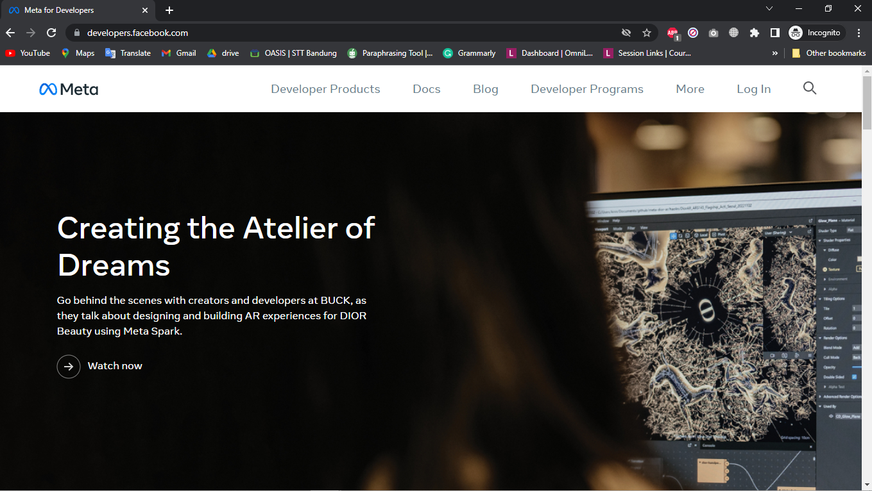
   2. **Login with your Facebook Account**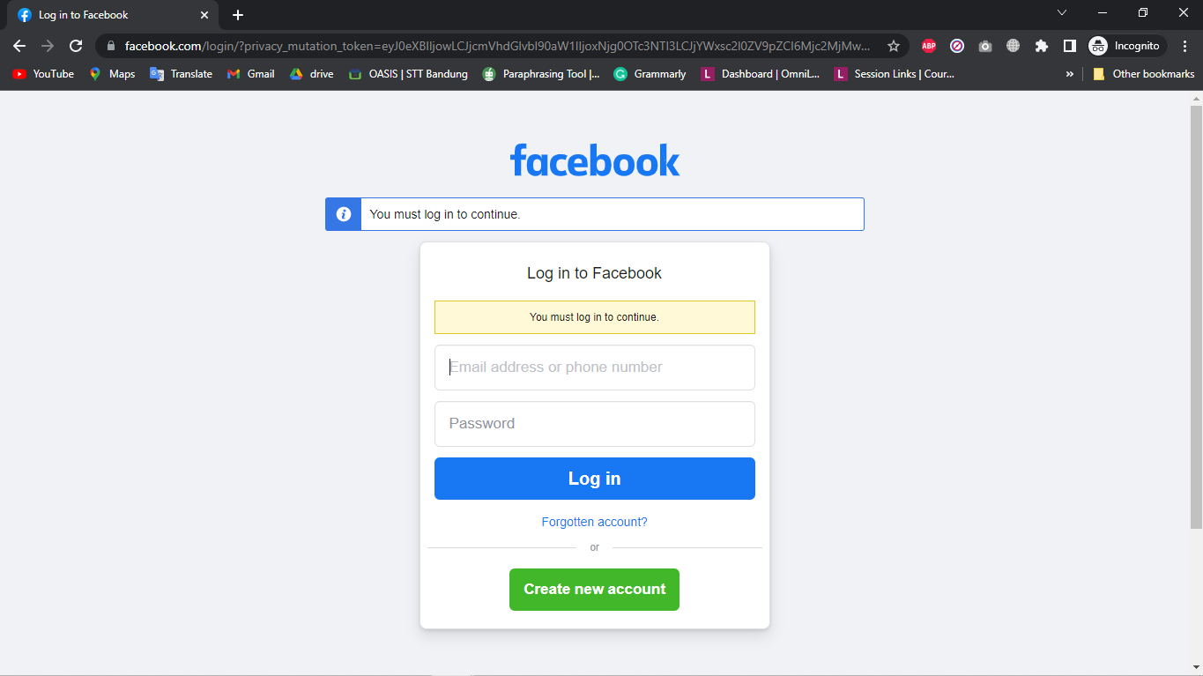

1. **Create New Application for using social integration.**
   1. **After you log in and verify your account, you will direct to create apps and click Create App.**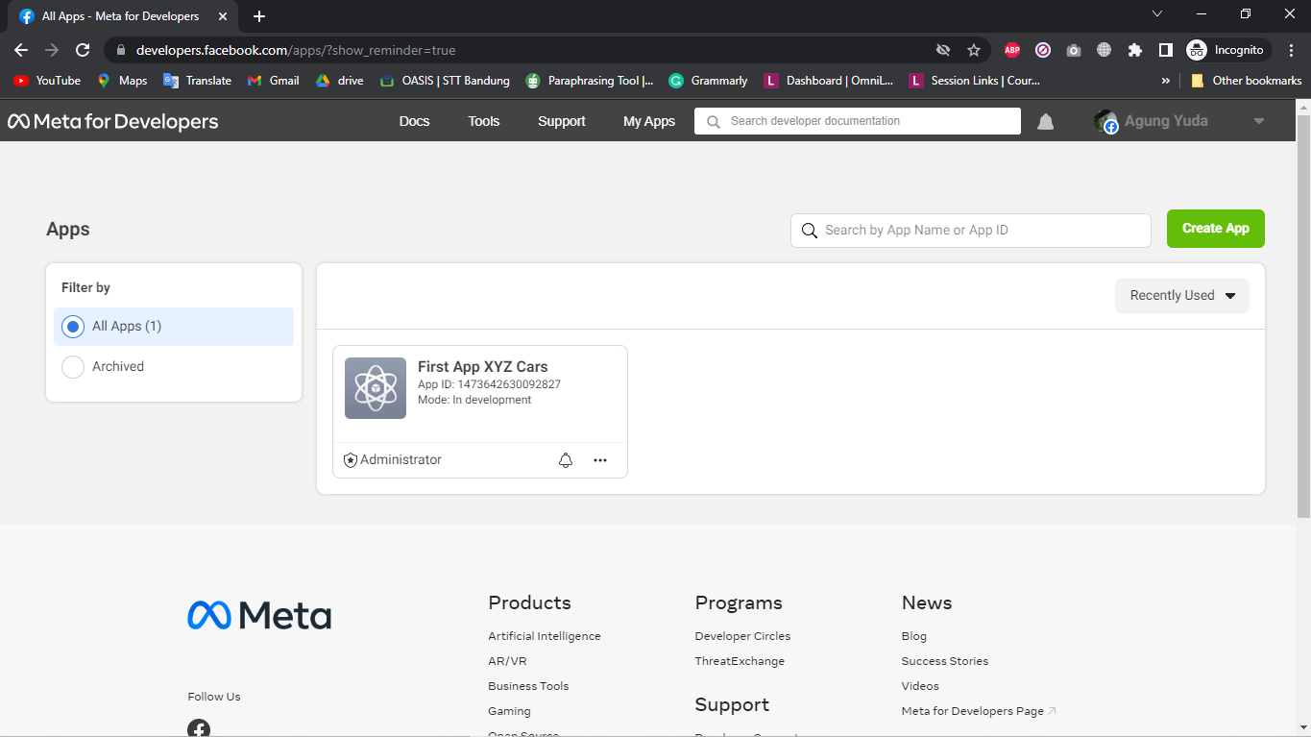
   2. **Choose Facebook Login**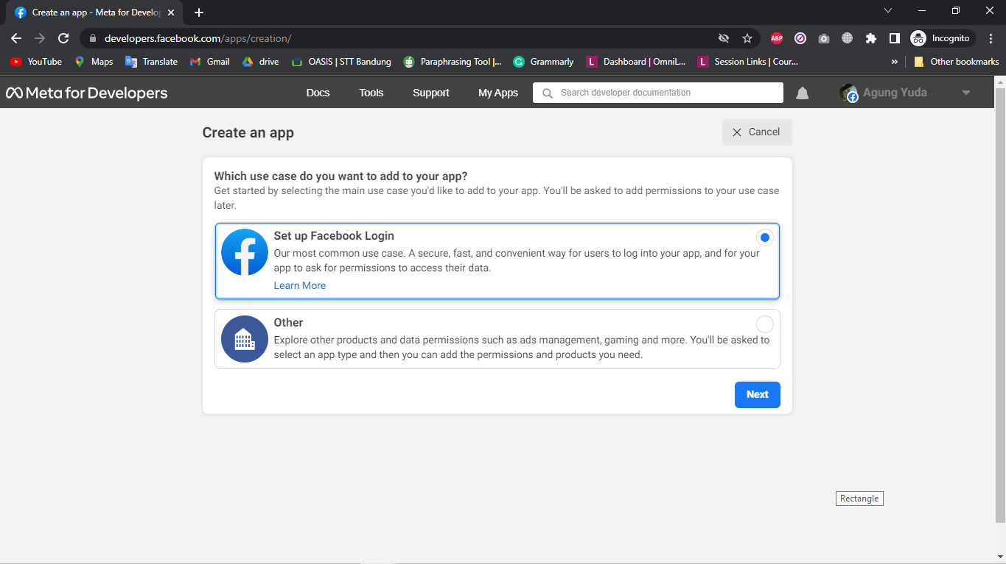
   3. **Checklist for your needs.**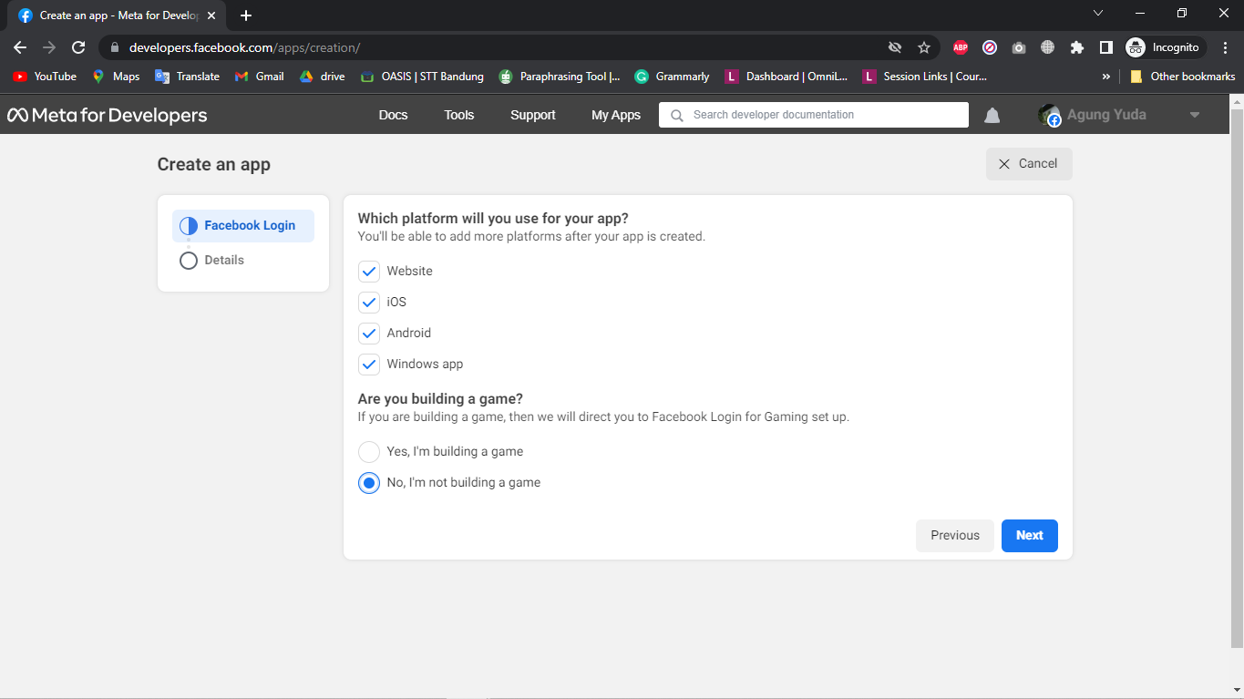
   4. **Add The App Name and click create App**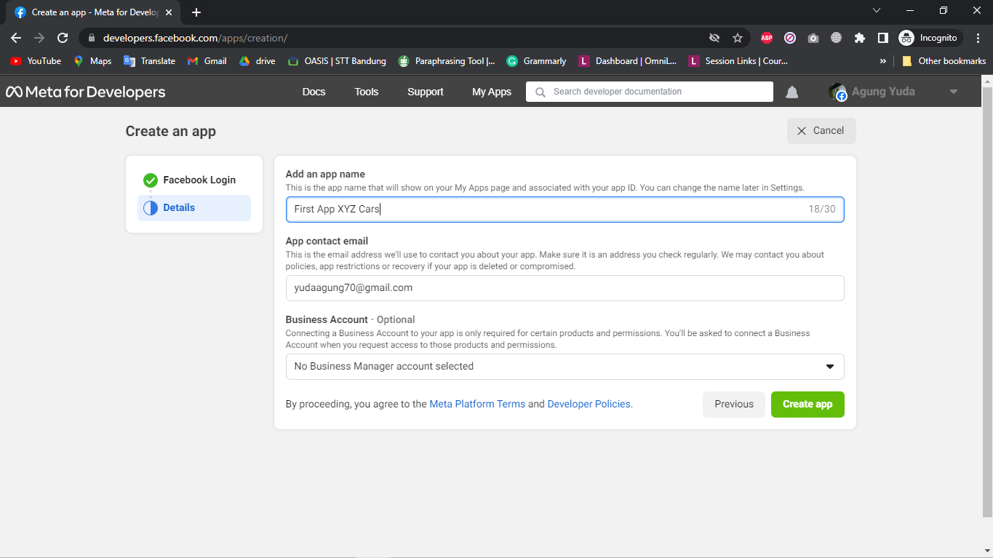
2. **Implement Social login using Facebook in XYZ cars Portal.**
   1. **UserController.java**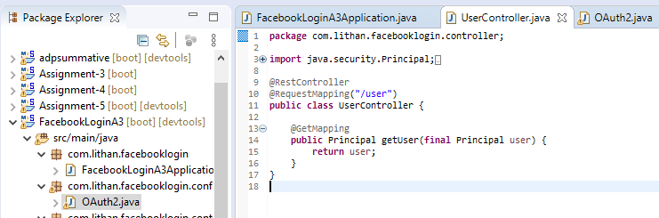
   2. **OAuth2.java**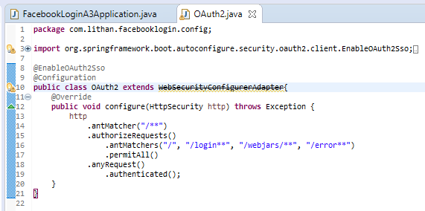
3. **Use created App Id and App Secret in Application.**
   1. **Open your App and go to setting => basic**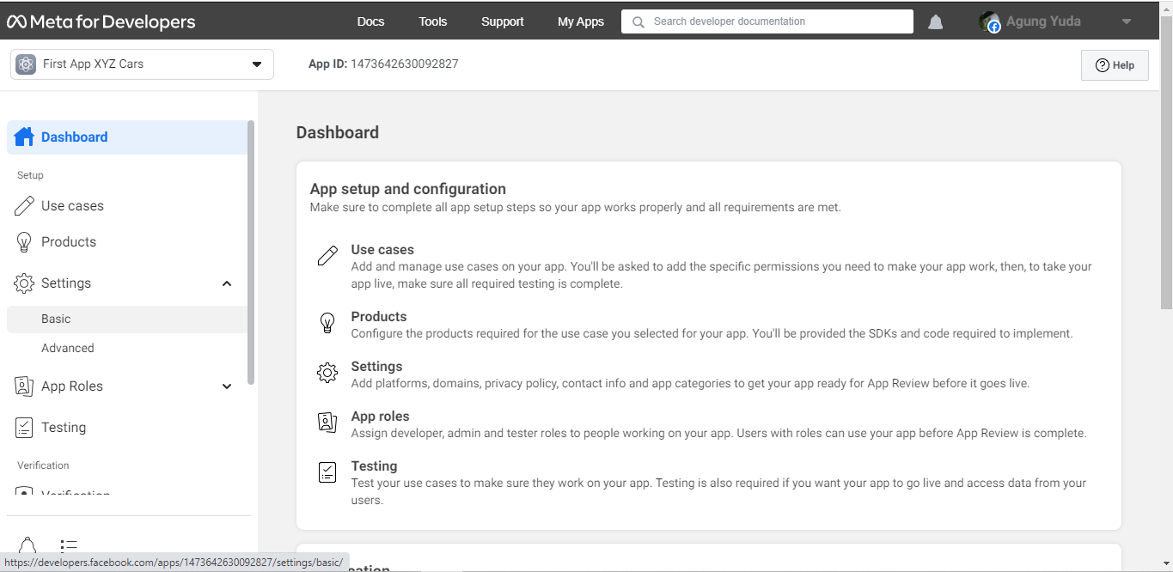
   2. **You can see App Id (for Client Id) and App Secret (for Client Secret)**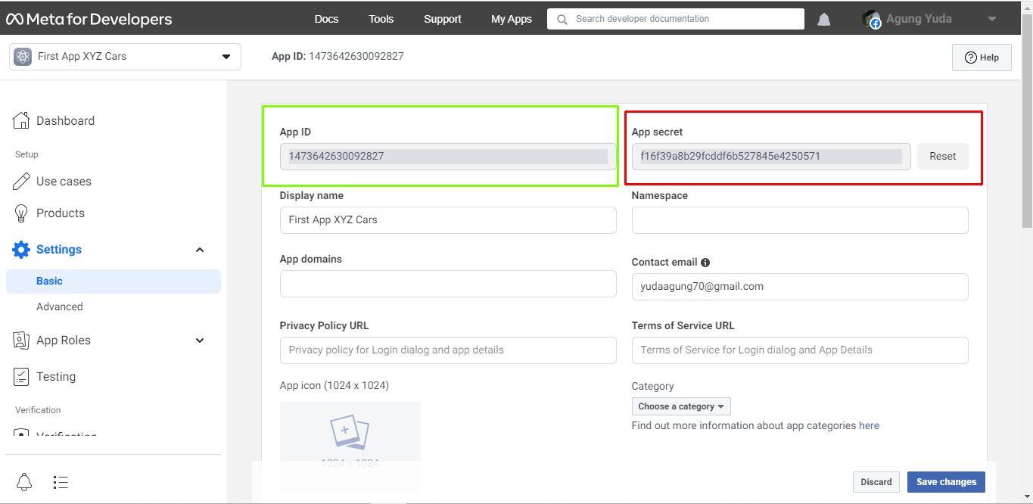
   3. **Put in your application.yml**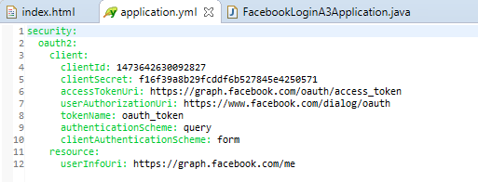
4. **Login using Facebook.**
   1. **This is the home page and click sign in**

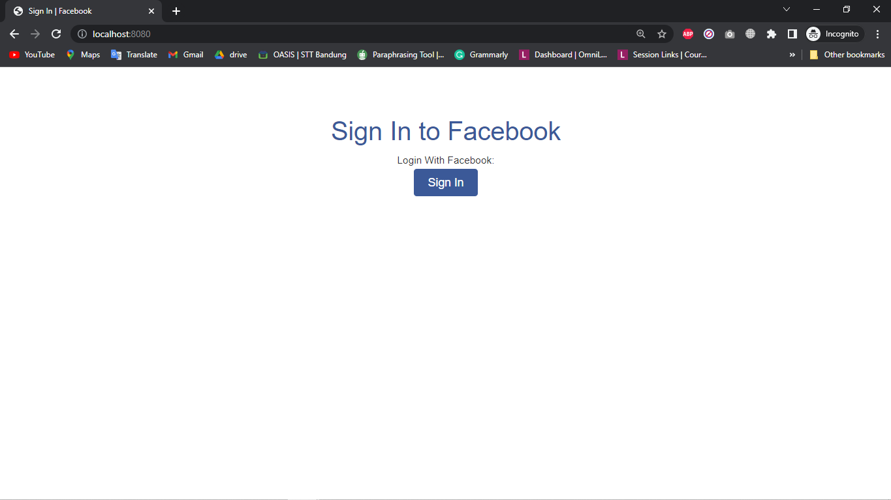

* 1. **Login with your Facebook Account**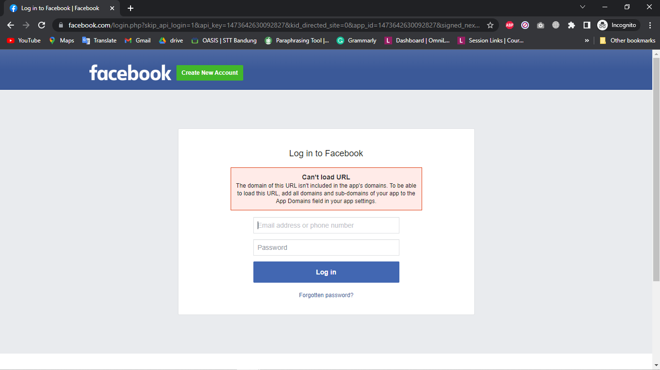
  2. **This is after login**